Online Safety Newsletter

April 2022

Parental Controls

Does your child have a game console? If yes, have you set up age-appropriate parental controls? The controls vary across the different consoles, but all will allow you to restrict spending and communication for example.

PlayStation
Set up your account as a family manager and create a separate child account so you can tailor their activities. Find out more here:
https://www.playstation.com/en-gb/support/account/psn-safety-parents-guide/

Xbox
You can download an app to manage your child’s gaming experience. Find out more here:
https://www.xbox.com/en-GB/apps/family-settings-app

Nintendo Switch
Nintendo also offer a free app to monitor what and how your children are playing. Find out more here: https://www.nintendo.co.uk/Nintendo-Switch-Family/Nintendo-Switch-Parental-Controls/Nintendo-Switch-Parental-Controls-1183145.html

Does your child want to be a YouTuber?

YouTube is intended for users over the age of 13, however the App store rates YouTube as 17+ due to the content that can be found on there.

Have you heard of Ryan Kaji? He is the face behind the YouTube channel Ryan’s World, which in 2021, earned a staggering £19m!! (Source: https://www.bbc.co.uk/news/entertainment-arts-59987711). Lots of YouTube channels centre around children so is it any wonder that many children aspire to have their own channel? How can we support and keep them safe though?


Posting videos
You should be over 13 years of age to post videos on YouTube. Talk to your child about posting videos, do they understand what information they should keep private and what to do if they receive negative comments? YouTube have produced these tips: https://support.google.com/youtube/answer/2802244

Select an appropriate setting for their videos
There are three different settings for videos published on YouTube:
- Public: anyone can view the video
- Private: video can only be viewed by users that you select
- Unlisted: only people who have the link to the video can view it.

Other tips:
- Explore comment settings – comments can be held for review, specific words can be blocked and ensure your child knows how to remove and report comments if necessary: https://support.google.com/youtube/answer/9483359
- Visit your child’s channel to see what videos they are posting
- Ensure your child knows how to block and report users if necessary.

How can I make YouTube safer?
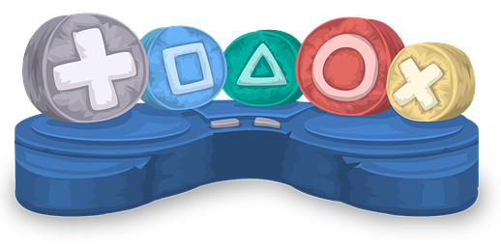
- Turn on Restricted mode as this restricts the availability of mature content. You will need to set up a Google account to do this.
- Explore YouTube together and see what they like to watch. Make sure your child understands that they can talk to you if they see anything that makes them feel uncomfortable online.
- Ensure your child knows how to report inappropriate content.
Users of this guide do so at their own discretion. No liability is entered into. Current as of the date released 1.04.22.

Go online together!

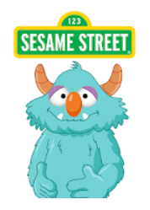
Breathe, Think, Do with Sesame (4+)
This app will help you teach your child skills such as problem solving, self-control and planning.

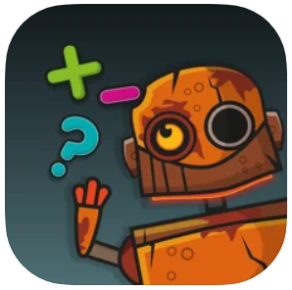
Numbots – app/website
(£7.20 per year for up to 3 children)
Engaging platform for learning to add and subtract. NumBots recommend children start using between the ages of 5 – 7 years old.


YouTube Kids (4+)
YouTube Kids was created to give children a more contained environment.
Remember not all videos have been manually reviewed so if you do find something then flag it for fast review.

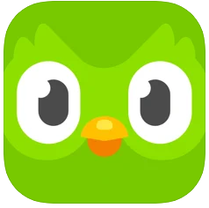
Duolingo - Language Lessons (4+)
Learn a new language or your child can practice what they’re learning in school. This app is free although a paid subscription is available for further functionality and no ads.

Online gaming at home
This is a useful video to watch from Andy Robertson (Editor of Ask About Games):
https://www.askaboutgames.com/news/askaboutgames-on-the-road-parent-club-advice

As with all apps, check their suitability for your child before they use it. Think about if it is appropriately aged for your child and how the app uses your data for example?

What’s in the news?
Children may come across news that upsets them, worries them, or makes them feel anxious. Newsround have produced this article which you can share and read with your child providing them with tips about what to do if they are feeling sad about the news:
- https://www.bbc.co.uk/newsround/13865002

How can I support my child?
The following two articles provide advice on how to help your child cope with the media coverage of traumatic events, for example the current news around Russia invading Ukraine:
- https://www.parents.parentzone.org.uk/morearticles/helping-your-child-cope-with-media-coverage-of-traumatic-events
- https://www.childline.org.uk/get-involved/articles/worrying-about-russia-ukraine/

Real or Fake?
A lot of children see or hear news updates from social media or via friends so it’s important that we talk to them about fake news and provide them with the skills to help them distinguish between real or fake news. So how do we get them to critically think about what they are reading? Here are some tips:
- Check the source (who wrote it).
- When was it written? Is it based on an old story?
- Is it on a reputable news site, for example Newsround?
- You can also use ‘fact checker’ sites such as https://fullfact.org/ to see if the news item has already been fact checked and linked to a credible source.

Further information
- https://www.bbc.co.uk/bitesize/articles/zmvdd6f
- https://www.internetmatters.org/resources/tackling-fake-news-misinformation-advice-for-parents/
Talking about Online Safety

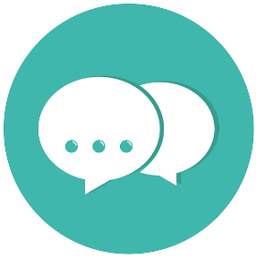
The NSPCC provide fantastic advice on how to start conversations about Online Safety with your child, where to get further support and how to be a good digital role model.

This site also includes Online safety family resources such as a family quiz, which is a great way to start conversations with your child whilst making it fun!

https://www.nspcc.org.uk/keeping-children-safe/online-safety/talking-child-online-safety

