Understanding the World

Geography: Know some similarities and differences between different religious and cultural communities in this country.

Understanding processes in the natural world in Wild Tribe.

Literacy

Focus books:
Same, Same but different
The Train Ride

Reading:
Identify the sounds.
Begin to blend sounds to make words.

Expressive Art and Design
(EAD)
DT
Junk modelling-modes of transport and communication.
Music
Charanga- ‘Big Bear Funk’




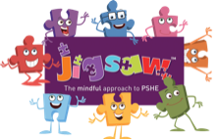



Writing:
Correct letter formation
Identify and write the sounds in words.

EYFS
Summer term 1

Big Wide World

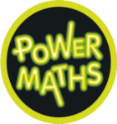
Maths
- Patterns
- Adding by counting on
- Taking away by counting back
- Counting to and from 20

Physical Development (PD)
Athletics
Wild Tribe

How can you support your child at home?
- Recap RWI sounds with them.
- Discuss the books you share together.
- Encourage your child to play Numbots regularly
Communication and Language (CL)
Use new vocabulary within our play.
Begin to listen with focus and attention

Personal, social and emotional development. (PSED)
Relationships-
Learning about self and friends and family

