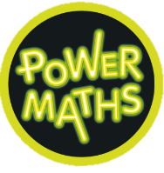
Geography
Migration – Migration around the world
History
Vikings – Lady of the Mercians
R.E
Christianity - Living Christian Traditions

 English
Reading: In guided reading, we will improve our fluency and comprehension skills using Re-think Reading, beginning with ‘A Drove of Bullocks’.
Our class novel is ‘Wild Boy’, which we will share daily.
Writing: We begin this half term by writing a short story inspired by ‘A Word in Your Ear’ by Tony Ross. The writing focus will be on the description of settings, characters, and atmosphere, while integrating dialogue to convey character and advance the action. This is followed by ‘The Everyday Journey of Ordinary Things’ where children will write a sequential explanation of the journey of an everyday thing and use layout devices to help the reader to follow the sequence and add additional details

Year 5: Autumn 2
Maths
This half term we are looking at Multiplication and Division multiplying three and four digit numbers by one and two digits and progressing onto problem solving using these methods.
We will then move on to fractions, where we will learn how to multiply a fraction by an integer, calculate a fraction of a quantity and find fractions of amounts.



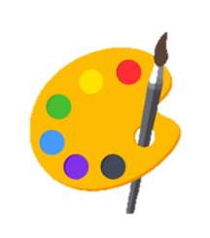
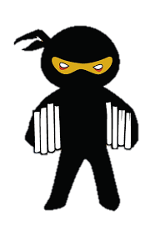
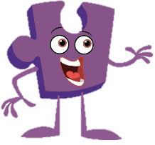



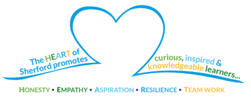
PSHE
Our Jigsaw PSHE focus is on Dreams and goals.

Physical Education
On Tuesdays, children will develop their basketball skills and learn how to apply and use them successfully in team games.
Computing
We will be continuing to learn about databases and
how to navigate them. We will then develop our own databases.

Art and design
This half term, we will be exploring the art of Monoprinting. This is the art of transferring ink or paint from a design to a surface.
Science
- We will be recapping and developing further knowledge of ‘Animals, including Humans’.
Music
We will continue to appraise pop ballads and compose our own music using a major scale.
How can you support your child at home?
Support your child in completing weekly homework, consisting of spellings, times table practice and independent reading.
Read to and with your child, asking them questions about the story they are reading.
Check Dojo regularly for class updates and information.

