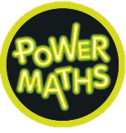


Maths
We will explore place value, looking at ordering and partitioning numbers. We will extend our learning to learn how to read and write numbers to 100 as well as counting in 2’s, 5’s 10’s and 3’s.

English
Reading
• Continue to develop accuracy and fluency when reading aloud.
• Talk about the books we have explored.
Writing – Oi Frog! By Kes James and Jim Field.
- Develop our phonic knowledge through reading and generating rhyming strings.
- Secure understanding of a sentence.
- Learn how to punctuate sentences using a range of punctuation.
- We will then write a series of our own silly rhyming sentences.
- We will write our own version of Oi Frog!

Geography – Where do I live?
- Use basic geographical vocabulary to refer to key physical and human features.
- Use aerial photographs and plan perspectives to recognise landmarks and basic human and physical features.
- Use simple fieldworkand observational skills to study the geography of our school and its grounds and the key human and physical features of its surrounding environment.


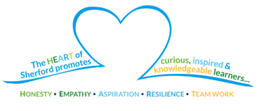


PE
PE days will be on Tuesdays and Thursdays this term.
- Explore movement skills using our bodies.
- Think about health and fitness follow instructions.
Year 2
Autumn 1
How can you support your child at home?
Read, discuss and record the books you read at home with your child in their reading record.
Encourage your child to complete 10 minutes of NumBots per day.
Check Dojo regularly for class updates and information.

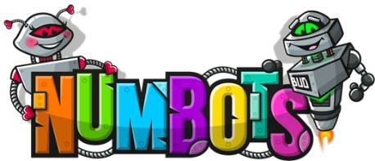

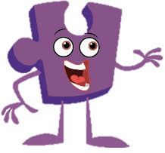
Art-Portraits
- We will be learning about famous portraits and creating our own.
Music -Hey You!
- Listen to an old-school hip-hop style song.
- Learn the differences between pulse, rhythm and pitch.
Science – Plants
By the end of this unit, we will be able to:
- Identify and name a variety of common wild and garden plants, including deciduous and evergreen trees.
- Identify and describe the basic structure of a variety of common flowering plants, including trees.

PSHE
Our Jigsaw PSHE focus is on ‘Being me’.
Wellbeing
- Think about how to become a responsible member of the school.
• Think about the choices we make and how to work cooperatively with others.

