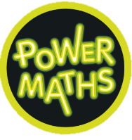
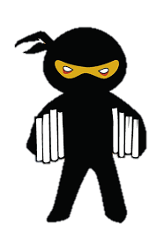
Year 5: Autumn 1
Maths
This half term we are looking at place value and numbers up to 1,000,000. We will be able to read, write, compare and order numbers of up to 7 digits, round numbers within 1,000,000, recognise and use negative numbers and solve problems relating to the above.
We will then move on to the four operations; studying multiplication and division in more depth.
Geography
Why is California so thirsty?
History
Islamic Civilisations: The round city, Baghdad.
Why were there so many restless minds in Cordoba and in Baghdad?
R.E
Islam: The stories of the prophets.
What do Muslims learn from the prophets as role models?
English
Reading: In guided reading we will be improving our fluency and comprehension skills through the use of Comprehension Ninja, studying fiction, non-fiction and poetry texts.
Our class novel is The Hunting of the Snark, by Lewis Carrol, which we will share on a daily basis.
Writing: We begin this half term by writing a modern fairy-tale inspired by the book The Tear Thief. We will study adverbial and noun phrases as well as exploring the use of dialogue. We will then move on to study the book Incredible Edibles. A science themed cook book full of revolting recipes and interesting facts.

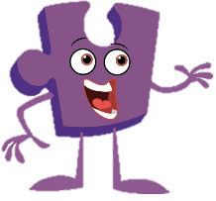


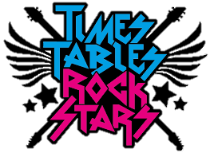

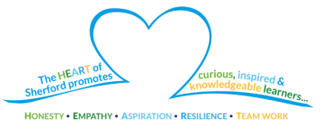
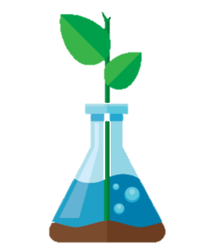
Music
We will be appraising pop ballads and composing our own music using a major scale.
Design and Technology
This half term we will be exploring an area of mechanical systems, focusing on the use of pulleys. We will be creating our own pulleys within a mechanical system, inspired by our favourite nursery rhymes.
PSHE
Our Jigsaw PSHE focus is on ‘Being me’.

Computing
Quizzing: the process of designing and creating interactive quizzes.

Physical Education
In our Games sessions we will be strengthening the hockey skills learned in Year 4, whilst further developing our teamwork skills.
In P.E the children will be studying Gymnastics, which will be led by an Arena coach.

How can you support your child at home?
Support your child in completing weekly homework, consisting of spellings, times table practice and independent reading.
Read to and with your child, asking them questions about the story they are reading.
Check Dojo regularly for class updates and information.
Science
Living things and their habitats
By the end of this unit, we will be able to:
- Describe the differences in life cycles of a bird, mammal, amphibian and insect.
- Describe the life process of reproduction in some plants and animals.

